Relational Databases with MySQL Week 2 Coding Assignment
Points possible: 70
Category | Criteria | % of Grade
Functionality | Does the code work? | 25
Organization | Is the code clean and organized? Proper use of white space, syntax, and consistency are utilized. Names and comments are concise and clear. | 25
Creativity | Student solved the problems presented in the assignment using creativity and out of the box thinking. | 25
Completeness | All requirements of the assignment are complete. | 25

Instructions: Using a text editor of your choice, write the queries that accomplishes the objectives listed below. Take screenshots of the queries and results and paste them in this document where instructed below. Create a new repository on GitHub for this week’s assignments and push this document, with your Java project code, to the repository. Add the URL for this week’s repository to this document where instructed and submit this document to your instructor when complete.
Coding Steps:
Write queries to address the following business needs.
1. I want to know how many employees with each title were born after 1965-01-01.
2. I want to know the average salary per title.
3. How much money was spent on salary for the marketing department between the years 1990 and 1992?

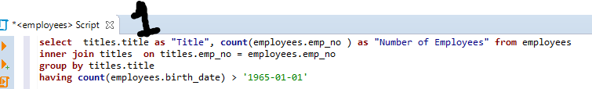
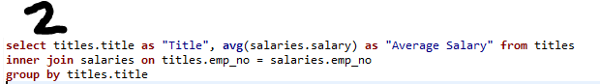
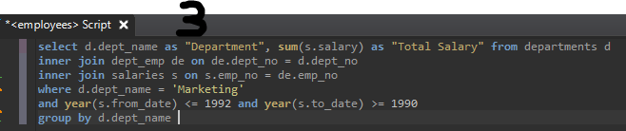
Screenshots of Queries:
Screenshots of Query Results (only include the last 20 rows):
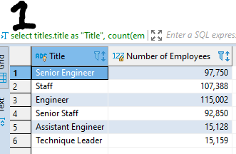
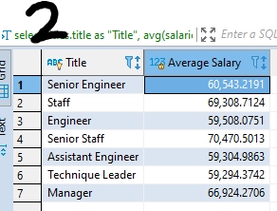

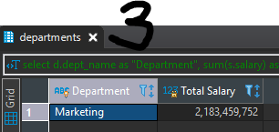
URL to GitHub Repository:

